**RAPPORT TD5 ETHEREUM**

**Creating a ticketing system**

1. Create a Git repository & share it with the teacher

Create a ticketing contract (2 pts)

1. Create function to create/modify an artist profile (2 pts)

• Name

• Artist type

• Total tickets sold

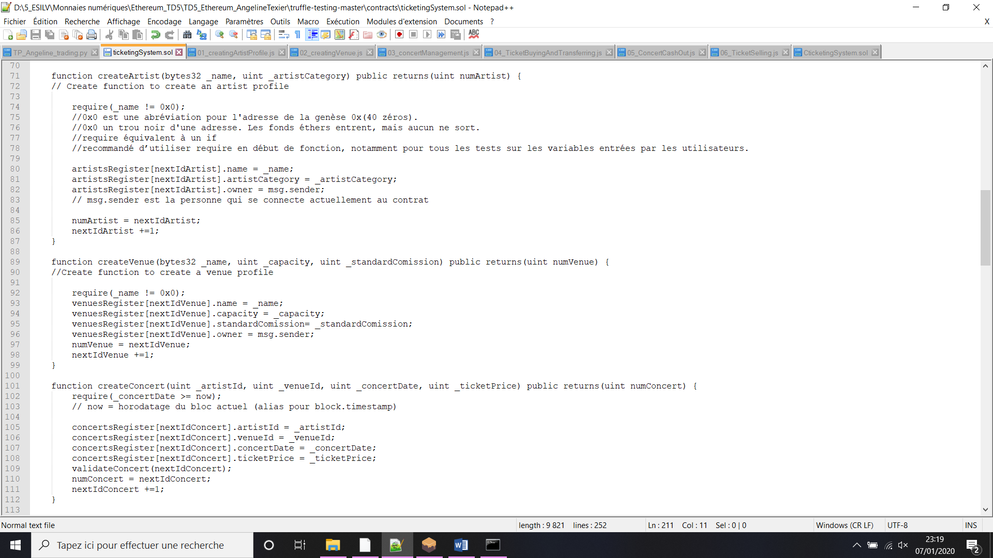

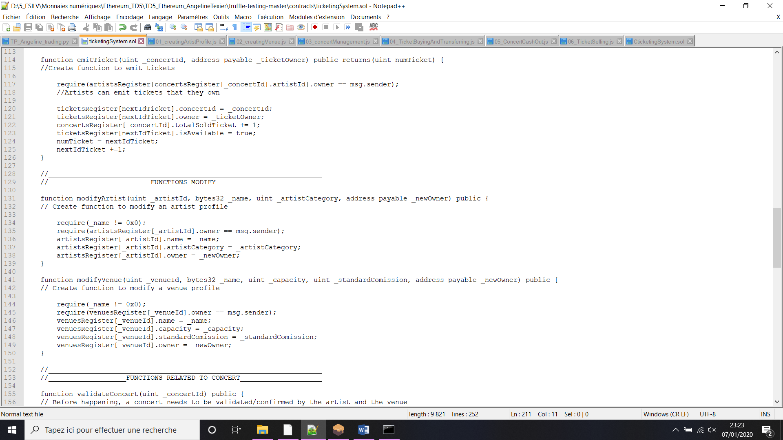

1. Create functions to create/modify a venue profile (2 pts)

• Name

• Space available

• % of ticket price going to venue





1. Create a concert object (2 pts)

• Include date of concert

• Include artist and venue id

• A concert object can be created by anyone



• Before happening, a concert needs to be validated/confirmed by the artist and the venue

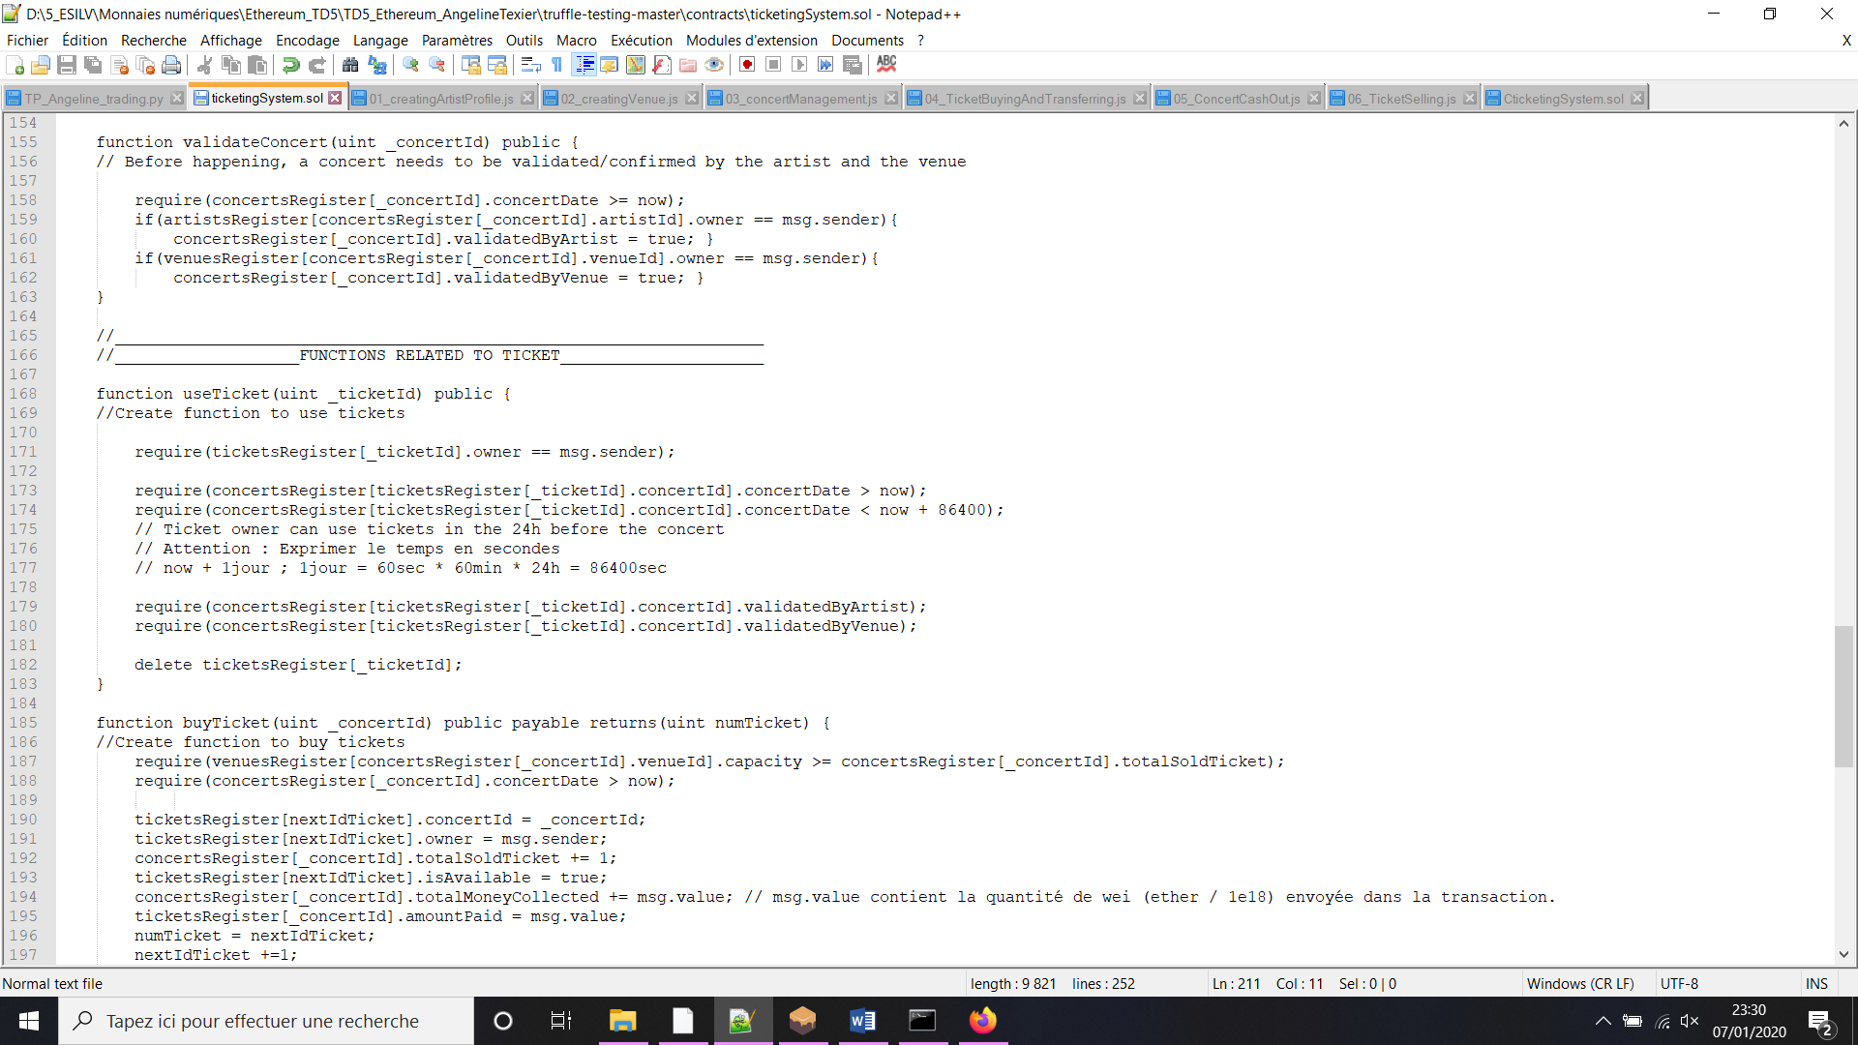

1. Create functions to emit tickets and use tickets (2 pts)

• Artists can emit tickets that they own

• Ticket owner can use tickets in the 24h before the concert





1. Create functions to buy and transfer tickets (2 pts)

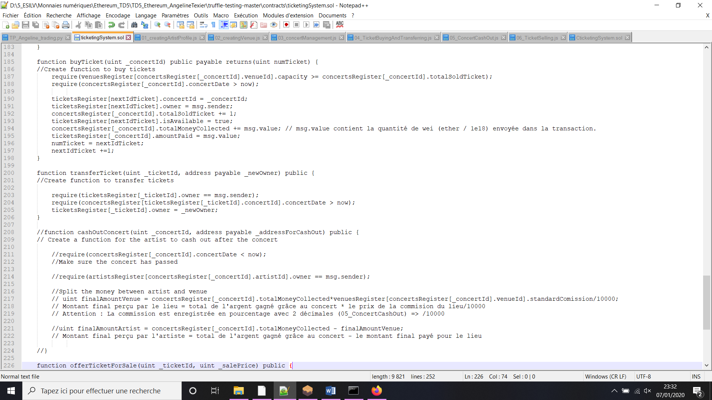



1. Create a function for the artist to cash out after the concert (3 pts)

• Make sure the concert has passed

• Split the money between artist and venue

Non terminé, ne fonctionne pas. Je l’ai donc mis en commentaire.



1. Create a function to safely trade ticket for money (3 pts)

• Forbid selling the ticket for more than it was bought

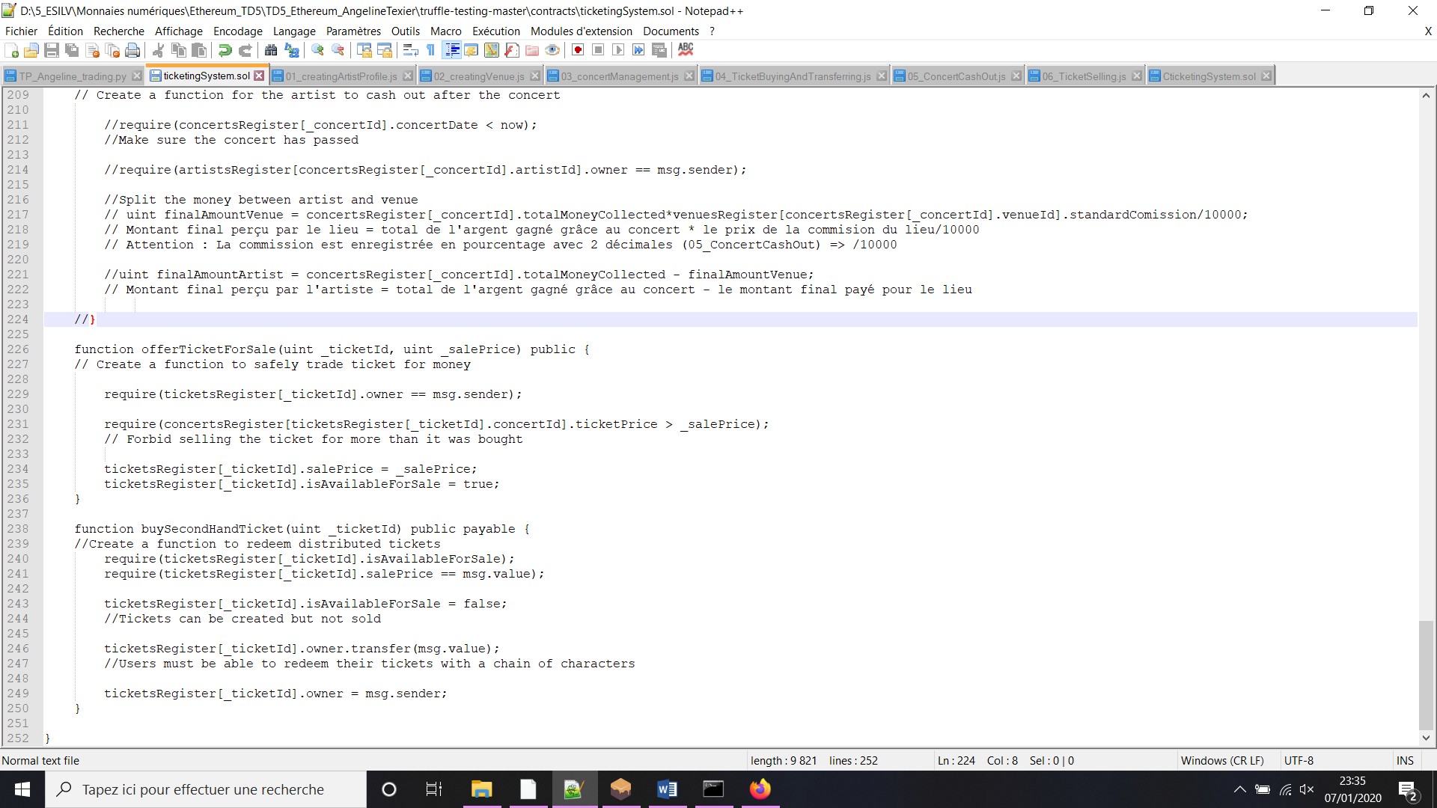

1. Create a function to redeem distributed tickets (3 pts)

• Tickets can be created but not sold

• Users must be able to redeem their tickets with a chain of characters



RUN TEST:

Il n’y a que le cash out qui est donc non valide comme je n’ai pas réussi à le finir.

